S2000E 扫路机
S2000E Road Sweeper
产品简介Product Introduction

长沙中联重科环境产业有限公司
Changsha Zoomlion Environment Industry CO.,LTD

2020-11-4

S2000E 扫路机产品简介
S2000e Sweeper Product Introduction

Product specification
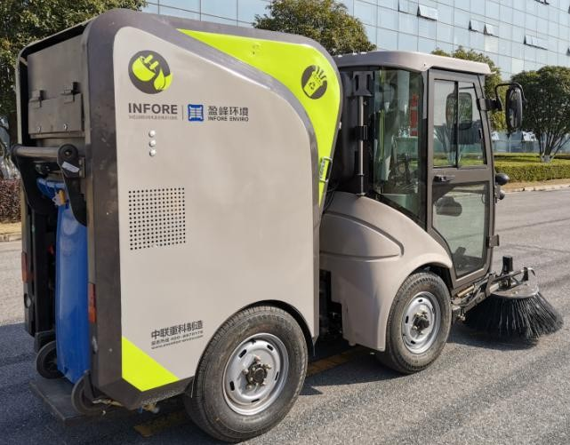
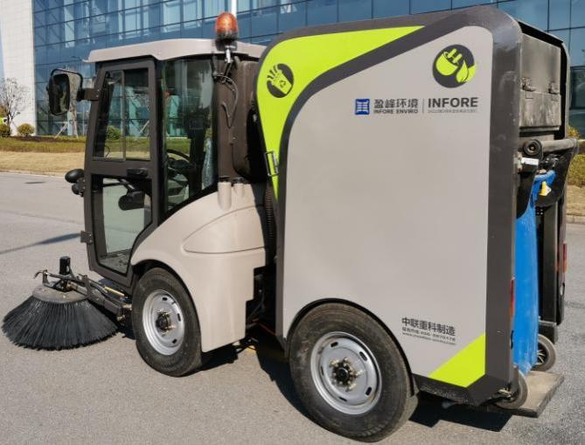
S2000E Pure electric mini sweeper with garbage bin is an articulated, 100% electric drive, 240L standard barrel sweeper innovated and developed by the company. It has the functions of road cleaning, dry dust removal, all day operation, garbage crushing and volume reduction collection, bucket changing and bag changing operation and auxiliary straw operation. The whole machine has beautiful appearance, flexibility and strong cleaning ability. It is especially suitable for cleaning and cleaning in narrow areas such as urban auxiliary roads, non motor vehicle lanes, sidewalks, pedestrian streets, scenic spots, parks, schools, scenic spots and residential quarters.

Functions

It has the functions of road cleaning, all-weather operation of dry dust removal, garbage crushing and volume reduction collection, bucket change and bag change collection, auxiliary straw suction and collection, etc. Pure electric mini sweeper with garbage bin adopts a dry dust removal system, which can operate all day. At the same time, it is equipped with a special crushing fan, which can realize garbage crushing and volume reduction collection and improve the single garbage collection volume. In addition, the 240L standard garbage can can be replaced quickly, and the garbage bag can also be used for rapid replacement for continuous cleaning operation to prolong the operation time. At the same time, it can also select an auxiliary suction pipe to manually absorb dirt and remove road pits Leaves and other garbage in roadside ditches, or use high-pressure water guns to clean stubborn garbage attached to roads and walls at fixed points.

Application
It is suitable for cleaning and cleaning in areas where large road sweepers cannot or are inconvenient to enter, such as urban auxiliary roads, narrow roads, non motorized lanes, sidewalks, pedestrian streets, scenic spots, parks, schools, scenic spots, residential quarters and so on.

Main structure &performance features
Pure electric mini sweeper with garbage bin adopts a pure electric chassis, equipped with mature and reliable three electric system, articulated frame, panoramic windshield cab, cooling and heating air conditioner, air suspension seat, steering wheel hydraulic steering system, electric rear axle driving system and low-speed and high load radial tire. The special devices include dry dust removal device, special crushing fan, 240L standard garbage can, cleaning device, suction nozzle, water spray dust reduction

system, hydraulic system, electric control system and other components. The main supporting parts are well-known brands in the industry, with excellent performance and reliable operation.
Driver's cab Auxiliary straw Special crushing fan Dry dedusting device 240L trash can

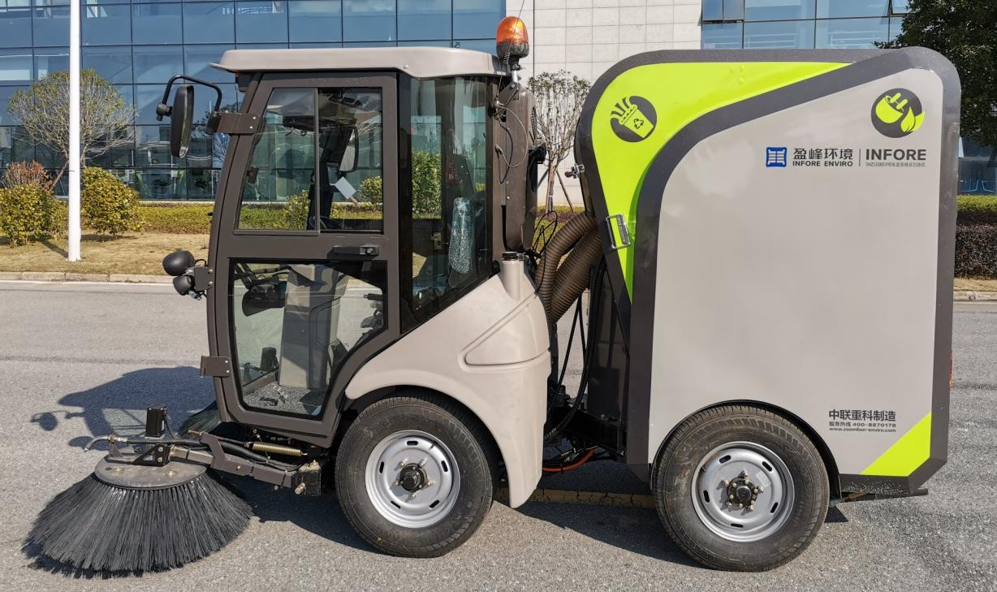
驾驶室
辅助吸管
专用破碎风机
干式除尘装置
240L 标准垃圾桶
清扫装置
吸嘴
清水箱
电控系统
液压系统
纯电直驱底盘

Cleaning device Suction nozzle Clean water tank Electric control system Hydraulic system Electric direct drive chassis

Main performance characteristics of sweeper:
- 240L standard garbage can is used to store garbage. The loading and unloading of the garbage can is flexible and convenient. It can quickly replace the garbage can. It can also be used with garbage bags to prolong the operation time. At the same time, it can carry out joint operation with the garbage transfer vehicle.
- The road sweeper adopts the air circulation back blowing and suction system, and the air flow is discharged after passing through the multi-stage filtering device. During the cleaning operation, there will be no secondary pollution of dust at the air outlet. At the same time, the suction nozzle adopts the back blowing structure to improve the suction efficiency, so as to realize the long-time operation of the road sweeper, which can be operated in sunny and rainy days.
- The dry dust removal system is adopted. The dust removal device adopts multi-stage filtration design, which can operate all day. At the same time, it is equipped with filter cloth vibrating device to remove the ash in real time, so as to ensure the filtering performance of filter cloth and realize long-term effective operation.
- The chassis is powered by lithium battery, which is green and pollution-free, with low operating noise and no disturbance to residents; The battery management system has perfect safety control strategy and thermal management strategy, which can work safely and stably even in severe cold and hot environment; Permanent magnet synchronous motor is directly connected to the rear axle for driving, which has high working efficiency and strong power. At the same time, braking energy recovery control is adopted, which has a long service life of the whole vehicle; The steering adopts articulated structure, with small turning radius and flexible steering operation, which is convenient for operation in a narrow space.
- The cab adopts panoramic windshield, with a horizontal visual angle greater than 270 °, and is equipped with air suspension seats. The driver can adjust the seat height and suspension air

pressure at any time according to his height and weight to achieve the most comfortable state. It is equipped with cold and warm air conditioning and multimedia equipment, and the driving environment is comfortable.
- The cleaning mechanism adopts automatic anti-collision structure and is equipped with integral sweeping plate. The motor is directly driven, and the speed control is convenient. At the same time, the cleaning mechanism and the suction nozzle adopt linkage control to realize synchronous lifting.
- The clean water tank is made of PE as a whole, the shape is matched with the cab, and the overall shape is beautiful. Combined with the dust reduction water path driven by the diaphragm pump, it acts on the left and right sweeping plates to achieve dust suppression. At the same time, the water flow of the sweeping plate dust reduction nozzle can be manually adjusted through the flow valve, and the dust can be suppressed continuously for more than 3 hours when filled with water at one time.
- The fan is made of wear-resistant steel with good wear resistance and crushing function. It can crush and reduce the capacity of garbage and improve the loading capacity of single bucket of garbage. At the same time, the fan adopts low-noise and energy-saving design, which can be used reliably for a long time to realize energy conservation and noise reduction in operation.
- The auxiliary suction pipe adopts flexible and high compression ratio retractable corrugated hose to meet the needs of manual suction operation.

- The high-pressure water circuit (one of two can be configured with the auxiliary suction pipe) adopts the international well-known brand three plunger high-pressure water pump, which is driven by hydraulic motor, with high efficiency and reliability.
- Constant speed cruise mode is set for cleaning operation, which can reduce leg fatigue and improve the quality of cleaning operation
- Lithium battery power is adopted for power, and the safety protection grade is IP67; High voltage platform and national standard charging interface are adopted to support fast charging of charging pile and mobile charger. When using charging pile for fast charging, it only takes 2H to fill.
- The key electric control driving components of the sweeper, such as motor and driver, are first-line brands, and the protection grade reaches IP67, safe, stable, mature and reliable.
- The road sweeper adopts automatic control system, color display operation, one button operation intelligent control and color video operation monitoring. The fan and sweeping plate can be adjusted steplessly within the set range to match the best operation scene.
- The sweeper adopts the control mode of "display + controller + CAN bus operation panel". When the operation starts and stops, the operation devices such as suction nozzle lifting, sweeping, retracting and releasing are all controlled by one key, which is easy to operate.
display. Located at the right front of the driver's seat, it is mainly used to display various

operation parameters, commissioning and fault diagnosis of the vehicle.
Operation box. The seat armrest on the right side of the driver's seat is mainly used for one key start and stop operation; Manual lifting and unfolding of sweeping plate; Speed adjustment of disc sweeping.
Operation panel. It is located above the right side of the cab and is mainly used for commissioning and maintenance.
The vehicle is equipped with color video rear view system. A camera is installed at the rear of the vehicle and a color display screen is installed in the cab. When reversing, the reversing video can be displayed in real time.

- Main technical parameters

Item | Unit | Parameter
Shapesize(lengths*width*height) | mm | 3400×1180×2000
Max total mass | kg | 2000
Curb mass | kg | 1750
Electric quantity | kW·h | 33
Maximum speed | km/h | ≥20
Max permissible gradient | % | ≥20
Min turning diameter | m | ≤2.25
Maximum sweeping width | mm | 2000

Operating speed | km/h | 0～8
Maximum operating capacity | m2/h | 16000
Garbage loading volume | L | 240L 标准垃圾桶
Clean water tank volume | L | 180
Working noise | dB（A） | ≤75
Continuous cleaning time | h | ≥6

- Main advantages

Superior performance
Flexible. Articulated steering, with minimum turning radius ≤ 2.25m and vehicle width of 1.18m, can work flexibly through various narrow areas. At the same time, the chassis is directly driven by permanent magnet synchronous motor, with strong power, and can work flexibly in and out of underground parking lots and other areas.
Strong operation endurance: The chassis traveling system adopts direct motor drive, with high working efficiency. At the same time, the operation device and its driving system adopt
energy-saving and efficient design, combined with braking energy recovery control, and the continuous operation time of the whole vehicle is long.
Good environmental protection performance: lithium battery, green power, zero emission and no environmental pollution. At the same time, the whole vehicle adopts electric direct drive system, which has high operation efficiency, low noise and does not disturb residents.

Many operation modes: In addition to the road cleaning operation mode, the cleaning operation is also equipped with constant speed cruise mode, which can reduce leg fatigue and improve the quality of cleaning operation. The whole machine adopts dry dust removal system, which can be operated all day. At the same time, it can use standard garbage cans for rapid replacement, and can also use garbage bags for rapid replacement. It can also cooperate with garbage transfer vehicles for combined operation. At the same time, it can also select auxiliary suction pipes for manual suction operation, which is convenient to remove garbage such as road pits and leaves in roadside ditches, Or use high-pressure water gun to clean the stubborn garbage attached to the road and wall at a fixed point.
Excellent driving comfort. The panoramic windshield cab has a visual angle of 270 °
and a wide operating vision. It is equipped with air suspension seats, which can be adjusted at any time according to the driver's height and weight. It is equipped with cold and warm air conditioning, and the driving environment is comfortable.

Excellent quality
High configuration of key components. The controller, motor, seat, steering gear and lamps are international famous brands, and the three power system is a famous brand in China, with excellent quality and high reliability.
Lightweight material selection. The clean water tank and all kinds of operation boxes and are

made of high-strength materials and formed by an integral mold. Light weight, high strength and beautiful shape.

Safe and reliable

High degree of self-control. Controller, color display, can bus control system, one touch operation. There are powerful, standard and economical three gear settings, which can be switched at any time during operation. High system reliability.
The electrical system is mature and reliable. Lithium ion battery is selected, and the battery management system is safe and efficient. The motor and driver shall be domestic first-line brands. The system matching is mature and reliable.

Various Functions
The machine is small and widely used. The width of the whole machine is only 1.18m, the turning radius is small, and narrow places can also be entered. Instead of manual machine scanning, it can complete the tasks that can not be completed by the road sweeper, and liberate the sanitation workers from heavy physical labor. In addition to cleaning the road, it can also cruise at a constant speed. The road sweeper adopts a dry dust removal system, which can operate all day. At the same time, it is equipped with a special crushing fan, which can reduce the capacity of waste crushing and improve the single waste collection. In addition, the standard garbage can can be replaced quickly, and the garbage bag can be replaced quickly for continuous cleaning, so as to

prolong the operation time, At the same time, the auxiliary suction pipe can be used to manually suck the dirt to remove the garbage such as road pits and leaves in roadside ditches, or the
high-pressure water gun can be used to clean the stubborn garbage attached to the road and walls at a fixed point.

Multi media functions. Standard radio, MP3 player, mobile phone charging and other functions.

Simple maintenance
Fault inquiry is convenient. The whole machine is equipped with a variety of sensors, and the fault problems can be queried directly through the display screen to accurately locate the fault point. The system has many functions, such as self diagnosis, early warning processing, emergency protection, fault analysis, operation record, accessories query and so on.

